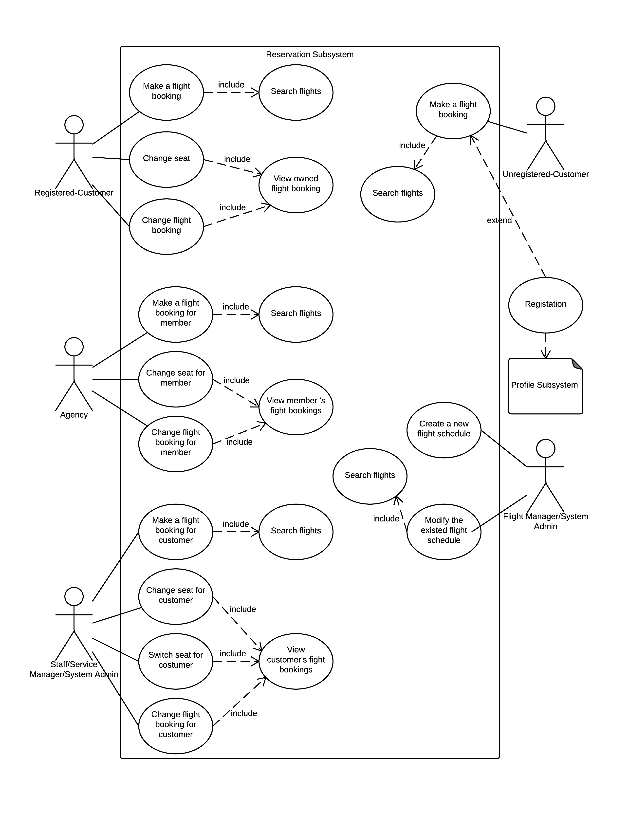Reservation Subsystem

|  |  |
| --- | --- |
| **Name: make a flight booking** | **ID: RS_01** |
| **Stakeholders and goals:**  System user (custom) – Want to use the system to book a flight | |
| **Description:** a custom will search a flight and use this function to book it | |
| **Actors:** custom | |
| **Trigger:** user want to book this ticket | |
| **Normal flow:**  1. The user selects flight they wish to book  2. The system brings up list of options (seat selection, in-flight services, passenger details (which include users account details as first passenger))  3. The user may select a seat they want  4. The user may select any in-flight services they want  5. The user fills in any additional passengers information  6. The user selects if they want any extra baggage  7. The system notifies the user of total price including any services purchased and displays a confirm booking button  8. The user confirms booking  9. The system sends a confirmation e-mail to user and notifies user of successful booking | |
| **Sub-flows:**   1. Loge in the account 2. Search fight | |
| **Alternative/Exceptional flows:**  None. | |

|  |  |
| --- | --- |
| **Name: search for Flight** | **ID: RS_02** |
| **Stakeholders and goals:**  Customer, staff, agency, manager, admin – Would like to look for the flight they wish to use | |
| **Description:** Customer, staff, agency, manager, admin use the time, departure city and destination city, to find a fit ticket for user | |
| **Actors:** Customer, staff, agency, manager, admin | |
| **Trigger:** Customer, staff, agency, manager, admin want to find a fit ticket | |
| **Normal flow:**  1. The user click to search for flights  2. The system displays a form of which to pick a date, destination and departure cities.  3. The user enters day they would like to depart on  4. The user enters city of departure  5. The user enters destination city  6. The user clicks search  7. The system displays all matching flights for specified time, destination and departure cities as well as alternative times within certain timeframe of specified time | |
| **Sub-flows:**   1. Loge in the account | |
| **Alternative/Exceptional flows:**  None. | |

|  |  |
| --- | --- |
| **Name: change seat** | **ID: RS_03** |
| **Stakeholders and goals:**  System user (custom) – Want to change his seat | |
| **Description:** custom want to choose a new seat | |
| **Actors:** custom | |
| **Trigger:** a custom think his old select is not good, so he want to change new seat | |
| **Normal flow:**  1. The system will display his all ticket.  2. custom choose one, and press the detail button  3. System will display all information about this flight.  4. custom input the seat number which he want to choose and press change seat button  5. System will output the success hint for custom. | |
| **Sub-flows:**   1. Loge in the account 2. Press the reservation button. 3. Press the my booking button about RS_04 | |
| **Alternative/Exceptional flows:**   1. if the seat had been chosen 2. system will display unsuccessful hint | |

|  |  |
| --- | --- |
| **Name: view owned fight booking** | **ID: RS_04** |
| **Stakeholders and goals:**  System user (custom) – Want to use the system to find his booking history | |
| **Description:** a custom want to get all ticket which he bought. | |
| **Actors:** custom | |
| **Trigger:** the custom want to check his booking history | |
| **Normal flow:**  1. The system have my booking button in reservation system  2. The user press this button  3. The system display all ticket and every tickets have a button which is “detail”. | |
| **Sub-flows:**   1. Loge in the account 2. Press the reservation button. | |
| **Alternative/Exceptional flows:**  None. | |

|  |  |
| --- | --- |
| **Name: change flight booking** | **ID: RS_05** |
| **Stakeholders and goals:**  System user (custom) – Want to use the system to change other flight. | |
| **Description:** a custom will cancel his old ticket and book a new flight | |
| **Actors:** custom | |
| **Trigger:** custom want to book a new ticket and didn’t want old one. | |
| **Normal flow:**  1. The system will display his all ticket.  2. custom choose one, and press the detail button  3. System will display all information about this flight.  4. Custom choose the change flight button.  5. System will skip a new page about search fight. (after this step, this is same as RS_02) | |
| **Sub-flows:**   1. Loge in the account 2. Press the reservation button. 3. Press the my booking button about RS_04 | |
| **Alternative/Exceptional flows:**  None. | |

|  |  |
| --- | --- |
| **Name: agency, staff, manager admin make a flight booking for member** | **ID: RS_06** |
| **Stakeholders and goals:**  System user (agency, staff, manager admin) – Want to use the system to book a flight for the custom | |
| **Description:** agency, staff, manager admin use custom’s information to book flight to them | |
| **Actors:** agency, staff, manager admin | |
| **Trigger:** custom want to other people help them to book flight. | |
| **Normal flow:**  1. The user selects flight they wish to book  2. The system brings up list of options (seat selection, in-flight services, passenger details (which include users account details as first passenger))  3. The user may select a seat they want  4. The user input the email about custom.  5. The user may select any in-flight services they want  6. The user fills in any additional passengers information  7. The user selects if they want any extra baggage  8. The system notifies the user of total price including any services purchased and displays a confirm booking button  9. The user confirms booking  10. The system sends a confirmation e-mail to user and notifies user of successful booking | |
| **Sub-flows:**   1. Loge in the account 2. Search fight | |
| **Alternative/Exceptional flows:**  None. | |

|  |  |
| --- | --- |
| **Name: view member’s fight booking** | **ID: RS_07** |
| **Stakeholders and goals:**  System user (agency, staff, manager admin) – Want to check the custom’s booking information | |
| **Description:** agency, staff, manager admin can use this system to check custom’s book history | |
| **Actors:** agency, staff, manager admin | |
| **Trigger:** agency, staff, manager admin want to view a custom’s booking history | |
| **Normal flow:**  1. The system have custom booking button in reservation system  2. The user press this button  3. the system will ask the custom’s email  4.user will input the email and press the next button  5. The system display all ticket and every tickets have a button which is “detail”. | |
| **Sub-flows:**   1. Loge in the account 2. Press the reservation button. | |
| **Alternative/Exceptional flows:**  None. | |

|  |  |
| --- | --- |
| **Name: change seat for custom** | **ID: RS_08** |
| **Stakeholders and goals:**  System user (agency, staff, manager admin) – Want to change seat for custom | |
| **Description:** agency, staff, manager admin help custom to change seat. | |
| **Actors:** custom | |
| **Trigger:** a custom think his old select is not good, so he want to change new seat, but he don’t know how to change, he let others help him. | |
| **Normal flow:**  1. The system will display his all ticket.  2. user choose one, and press the detail button  3. System will display all information about this flight.  4. user input the seat number which he want to choose and press change seat button  5. System will output the success hint for custom. | |
| **Sub-flows:**   1. Loge in the account 2. Press the reservation button. 3. Press the custom booking button about RS_07 | |
| **Alternative/Exceptional flows:**  1.if the seat had been chosen  2.system will display unsuccessful hint | |

|  |  |
| --- | --- |
| **Name: change flight booking** | **ID: RS_09** |
| **Stakeholders and goals:**  System user (agency, staff, manager admin) – Want to use the system to help custom change other flight. | |
| **Description:** agency, staff, manager admin want to help custom to cancel his old ticket and book a new flight | |
| **Actors:** agency, staff, manager, admin | |
| **Trigger:** custom want to book a new ticket and didn’t want old one, but he don’t know how to do it, so he let others to help him | |
| **Normal flow:**  1. The system will display his all ticket.  2. custom choose one, and press the detail button  3. System will display all information about this flight.  4. Custom choose the change flight button.  5. System will skip a new page about search fight. (after this step, this is same as RS_02) | |
| **Sub-flows:**   1. Loge in the account 2. Press the reservation button. 3. Press the custom booking button about RS_07 | |
| **Alternative/Exceptional flows:**  None. | |

|  |  |
| --- | --- |
| **Name: switch seat for custom** | **ID: RS_10** |
| **Stakeholders and goals:**  System user (staff, manager admin) – switch two customs’ seat | |
| **Description:** staff, manager admin use this system to switch a custom’s seat | |
| **Actors:** **staff, manager admin** | |
| **Trigger:** custom want to switch seats, so he let them help him | |
| **Normal flow:**  1. The system will display his all ticket.  2. user choose one, and press the detail button  3. System will display all information about this flight.  4. user select aim seat and press the change seat button  5. System will output the success hint for custom. | |
| **Sub-flows:**   1. Loge in the account 2. Press the reservation button. 3. Press the custom booking button about RS_07 | |
| **Alternative/Exceptional flows:**  None. | |

|  |  |
| --- | --- |
| **Name: create a new flight schedule** | **ID: RS_11** |
| **Stakeholders and goals:**  flight manager, admin want to create a new flight | |
| **Description:** flight manager admin want to create a new flight and set the flight’s time, departure place, arrived place | |
| **Actors:** flight manager, admin | |
| **Trigger:** admin,flight manager think company need have more flight | |
| **Normal flow:**  1. The system have a button about create flight  2. user press this button  3. System will display a list of options.(flight’s model, flight time, departure place, arrived place  4. user select the light model  5.user select the fight time  6. User filled the departure place.  7. User filled the arrived place.  8.User press the create button.  9. System will output a hint for successful | |
| **Sub-flows:**   1. Loge in the account 2. Press the reservation button. | |
| **Alternative/Exceptional flows:**  1. Some details do not fill. | |

|  |  |
| --- | --- |
| **Name: modify the existed flight schedule** | **ID: RS_12** |
| **Stakeholders and goals:**  flight manager, admin want to modify flight detail | |
| **Description:** flight manager admin want to modify flight detail and change the flight’s time, departure place, arrived place and price | |
| **Actors:** flight manager, admin | |
| **Trigger:** admin,flight manager think some flights need to modify | |
| **Normal flow:**  1. The system will display this fight information  2. Custom choose the modify button.  3. System will display a list of options.(flight’s model, flight time, departure place, arrived place  4. user select the light model  5.user select the fight time  6. User filled the departure place.  7. User filled the arrived place.  8. User press the modify button.  9. System will output a hint for successful | |
| **Sub-flows:**   1. Loge in the account 2. Press the reservation button. 3. Press the modify flight button about RS_13 | |
| **Alternative/Exceptional flows:**  1. Some details do not fill. | |

|  |  |
| --- | --- |
| **Name: manager search flight to set** | **ID: RS_13** |
| **Stakeholders and goals:**  flight manager, admin want to search a flight | |
| **Description:** flight manager admin want to search a flight | |
| **Actors:** flight manager, admin | |
| **Trigger:** admin,flight manager want to find a flight, and modify it. | |
| **Normal flow:**  1. The system will modify flight button  2. User can choose it.  3. System will display some option to fill  4. Customs fill the departure place and arrive place. And press next button  5. System will display this flight information. | |
| **Sub-flows:**   1. Loge in the account 2. Press the reservation button. | |
| **Alternative/Exceptional flows:**  1. Some details do not fill. | |

|  |  |
| --- | --- |
| **Name: make a flight booking about unregistered custom** | **ID: RS_14** |
| **Stakeholders and goals:**  System user (***unregistered custom***) – Want to use the system to book a flight | |
| **Description:** unregistered custom will search a flight and use this function to book it | |
| **Actors:** unregistered custom | |
| **Trigger:** user want to book this ticket | |
| **Normal flow:**  1. The user selects flight they wish to book  2. The system brings up list of options (seat selection, in-flight services, passenger details (which include users account details as first passenger))  3. The user may select a seat they want  4. The user may select any in-flight services they want  5. The user fills in any additional passengers information  6. The user selects if they want any extra baggage  7. The system notifies the user of total price including any services purchased and displays a confirm booking button  8. The user confirms booking  9. the system skip to a registration page (PS_01)  10. User complete that.  9. The system sends a confirmation e-mail to user and notifies user of successful booking | |
| **Sub-flows:**   1. Loge in the account 2. Search fight | |
| **Alternative/Exceptional flows:**  None. | |

|  |  |
| --- | --- |
| **Name: search for Flight about unregistered custom** | **ID: RS_15** |
| **Stakeholders and goals:**  unregistered custom – Would like to look for the flight | |
| **Description:** **unregistered custom** use the time, departure city and destination city, to find a fit ticket for user | |
| **Actors: unregistered custom** | |
| **Trigger:** unregistered custom want to search a flight | |
| **Normal flow:**  1. in the home page system list many option for user  2. The user enters day they would like to depart on  3. The user enters city of departure  4. The user enters destination city  5. The user clicks search  6. The system displays all matching flights for specified time, destination and departure cities as well as alternative times within certain timeframe of specified time | |
| **Sub-flows:**  None. | |
| **Alternative/Exceptional flows:**  None. | |

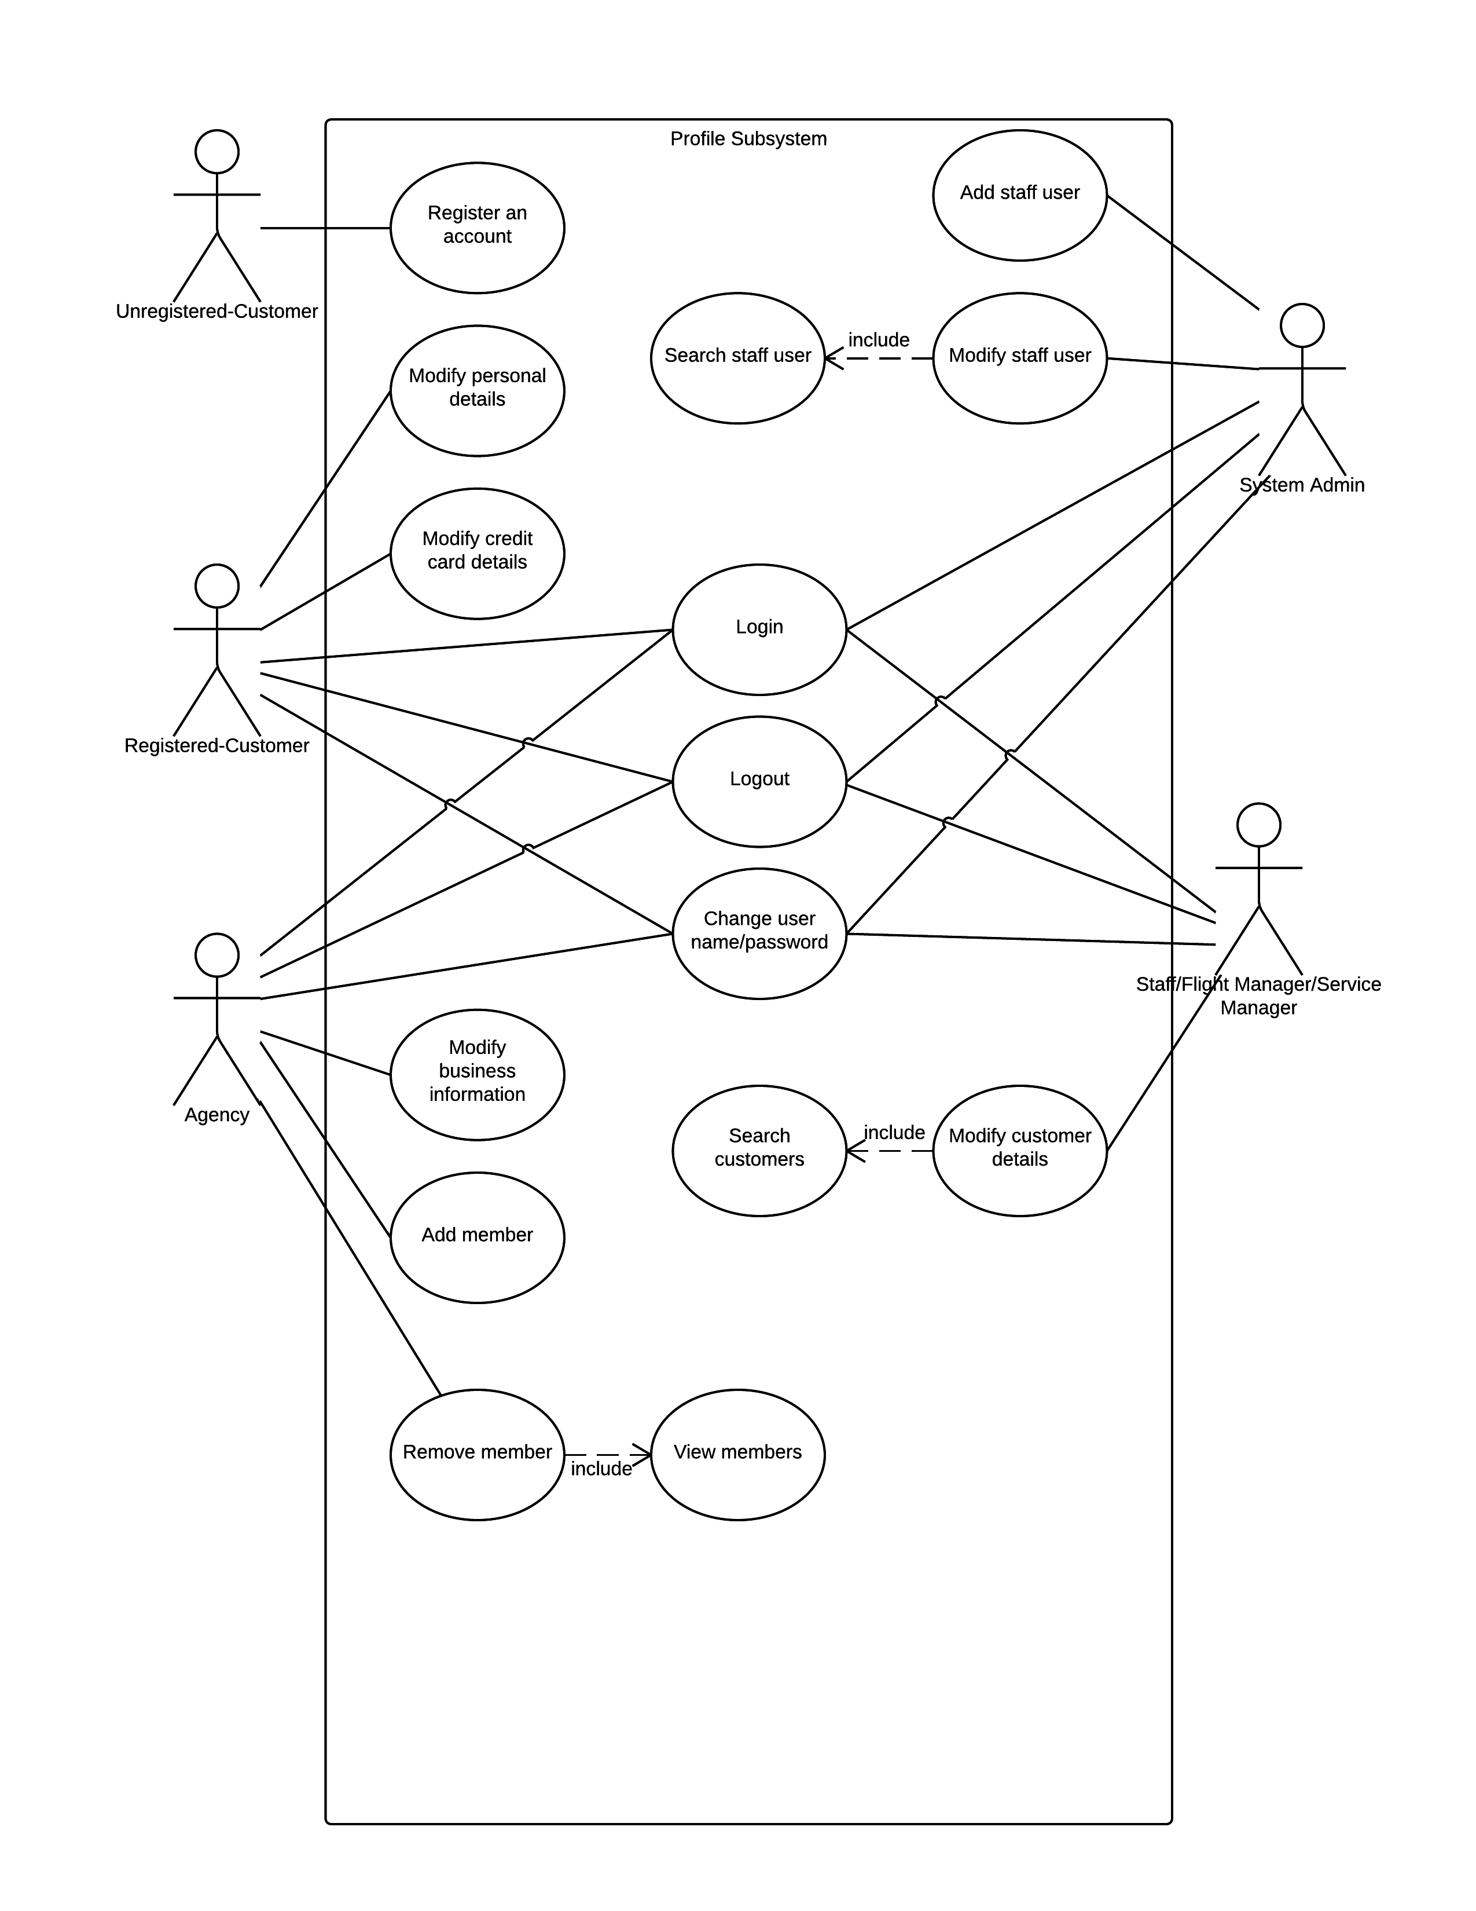Profile Subsystem

|  |  |
| --- | --- |
| **Name: register an account** | **ID: PS_01** |
| **Stakeholders and goals:**  unregistered custom – want to become a member | |
| **Description:** **User enters details to create an account on the system** | |
| **Actors: unregistered custom** | |
| **Trigger:** unregistered custom want to become a member | |
| **Normal flow:**  1. in the home page system have a button that is register  2. The user press this button  3.system list lots of option about individual information  4. The user enters title, phone, name, city, birthday, state, country, credit information, passport selection, and password, then press submit  5. The system will skip to custom page. | |
| **Sub-flows:**  None. | |
| **Alternative/Exceptional flows:**  None. | |

|  |  |
| --- | --- |
| **Name: login the account** | **ID: PS_02** |
| **Stakeholders and goals:**  All user – want to login their account | |
| **Description:** **The user enters in a username and password to login to the system** | |
| **Actors: custom, Agent, Staff, Manager, Admin** | |
| **Trigger:** user want to go to their account and do something | |
| **Normal flow:**  1. In the home page system have log in label.  2. The user input the email address and password, then press the login button  3.system skip to their account | |
| **Sub-flows:**  None. | |
| **Alternative/Exceptional flows:**  None. | |

|  |  |
| --- | --- |
| **Name: logout the account** | **ID: PS_03** |
| **Stakeholders and goals:**  All user – want to logout their account | |
| **Description:** **The user don’t want to use this account, so they want to out.** | |
| **Actors: custom, Agent, Staff, Manager, Admin** | |
| **Trigger:** user want to go out about account | |
| **Normal flow:**  1. in right of page have a logout button  2. The user press that button  3. System skip to homepage. | |
| **Sub-flows:**   1. Log in.(PS_02) | |
| **Alternative/Exceptional flows:**  None. | |

|  |  |
| --- | --- |
| **Name: change password or username** | **ID: PS_04** |
| **Stakeholders and goals:**  All user – want to change new password or username | |
| **Description:** **The user want to get a new username or password** | |
| **Actors: custom, Agent, Staff, Manager, Admin** | |
| **Trigger:** user want to change new password or username | |
| **Normal flow:**  1. system have a modify username and password selection  2. The user press that button  3. System display 3 options about old password, new password and username.  4. When user fill them, and press submit button  5. A hint which is success report will display. | |
| **Sub-flows:**   1. Log in.(PS_02) 2. Press the profile system button. | |
| **Alternative/Exceptional flows:**  None. | |
| **Name: change personal detail** | **ID: PS_05** |
| **Stakeholders and goals:**  All user(custom) – want to change their personal detail | |
| **Description:** **The user want to update their personal detail** | |
| **Actors: custom** | |
| **Trigger:** user want to **update their personal detail** | |
| **Normal flow:**  1. system have a change personal detail selection  2. The user press that button  3. System display lots of option about personal detail  4. When user fill them, and press submit button  5. A hint which is success report will display. | |
| **Sub-flows:**   1. Log in.(PS_02) 2. Press the profile system button. | |
| **Alternative/Exceptional flows:**  None. | |

|  |  |
| --- | --- |
| **Name: change credit card detail** | **ID: PS_06** |
| **Stakeholders and goals:**  All user(custom) – want to change credit card detail | |
| **Description:** **The user want to update their credit card detail.** | |
| **Actors: custom** | |
| **Trigger:** user have new credit card, so they want to update it. | |
| **Normal flow:**  1. system have a change credit card detail selection  2. The user press that button  3. System display some option about credit card detail.  4. When user fill them, and press submit button  5. A hint which is success report will display. | |
| **Sub-flows:**   1. Log in.(PS_02) 2. Press the profile system button. | |
| **Alternative/Exceptional flows:**  None. | |

|  |  |
| --- | --- |
| **Name: modify business information** | **ID: PS_07** |
| **Stakeholders and goals:**  All user (agency) – want to use the system to modify business information. | |
| **Description:** **The user want to update their name, email and phone.** | |
| **Actors: agency** | |
| **Trigger:** user have new business information | |
| **Normal flow:**  1. system have a business information selection  2. The user press that button  3. System display some option about name, email and phone.  4. When user fill them, and press submit button  5. A hint which is success report will display. | |
| **Sub-flows:**   1. Log in.(PS_02) 2. Press the profile system button. | |
| **Alternative/Exceptional flows:**  None. | |

|  |  |
| --- | --- |
| **Name: add new member** | **ID: PS_08** |
| **Stakeholders and goals:**  All user (agency) – want to add new member. | |
| **Description:** **The user use custom email to add new member** | |
| **Actors: agency** | |
| **Trigger:** have custom want to join this agent. | |
| **Normal flow:**  1. system have a custom information selection  2. The user press that button  3. System display all member and have a text label about email.  4. When user fill the email, and press the add button  5. System will display this member in the list. | |
| **Sub-flows:**   1. Log in.(PS_02) 2. Press the profile system button. | |
| **Alternative/Exceptional flows:**  None. | |

|  |  |
| --- | --- |
| **Name: delete member** | **ID: PS_09** |
| **Stakeholders and goals:**  All user (agency) – want to use the system to delete some member | |
| **Description:** **The user want to delete member from the list** | |
| **Actors: agency** | |
| **Trigger:** user want to delete the member | |
| **Normal flow:**  1. system display all member  2. The user select one of them and press delete button  3. System will remove this member from the list. | |
| **Sub-flows:**   1. Log in.(PS_02) 2. Press the profile system button. 3. Press the custom information button | |
| **Alternative/Exceptional flows:**  None. | |

|  |  |
| --- | --- |
| **Name: view member** | **ID: PS_10** |
| **Stakeholders and goals:**  All user (agency) – want to view their member | |
| **Description:** **The user want to system display all member** | |
| **Actors: agency** | |
| **Trigger:** user want to view all member | |
| **Normal flow:**  1. System have custom information button.  2. The user press that button  3. System will display all member and their information. | |
| **Sub-flows:**   1. Log in.(PS_02) 2. Press the profile system button. | |
| **Alternative/Exceptional flows:**  None. | |

|  |  |
| --- | --- |
| **Name: add staff user** | **ID: PS_11** |
| **Stakeholders and goals:**  All user (admin) – want to add new staff user | |
| **Description:** **The user can increase staff by their information.** | |
| **Actors: admin** | |
| **Trigger:** user want to add more staff | |
| **Normal flow:**  1. System have create staff button.  2. The user press that button  3. System will display some text label about username, password and position.  4.the user will fill it and press add button  5. A hint which is success report will display. | |
| **Sub-flows:**   1. Log in.(PS_02) 2. Press the profile system button. | |
| **Alternative/Exceptional flows:**  None. | |

|  |  |
| --- | --- |
| **Name: search staff user** | **ID: PS_12** |
| **Stakeholders and goals:**  All user (admin) – want to search staff user | |
| **Description:** **The user want to search staff user and modify it.** | |
| **Actors: admin** | |
| **Trigger:** user want to search staff user | |
| **Normal flow:**  1. System have modify staff button.  2. The user press that button  3. System ask the email.  4.the user will fill it and press submit button  5. this user’s information will display. | |
| **Sub-flows:**   1. Log in.(PS_02) 2. Press the profile system button. | |
| **Alternative/Exceptional flows:**  None. | |

|  |  |
| --- | --- |
| **Name: modify staff user** | **ID: PS_13** |
| **Stakeholders and goals:**  All user (admin) – want to modify staff | |
| **Description:** **The user want to search staff user and modify their username, password.** | |
| **Actors: admin** | |
| **Trigger:** user want to modify staff’s information. | |
| **Normal flow:**  1. System display this text label about position, username and password.  2. The user fill them, if he want to change, press the submit button.  3. System will display success hint. | |
| **Sub-flows:**   1. Log in.(PS_02) 2. Press the profile system button. 3. Search staff (PS_11) | |
| **Alternative/Exceptional flows:**  None. | |

|  |  |
| --- | --- |
| **Name: search custom** | **ID: PS_14** |
| **Stakeholders and goals:**  All user (staff and managers) – want to search custom | |
| **Description:** **The user want to search custom and modify them.** | |
| **Actors: staff and managers** | |
| **Trigger:** user want to search custom to modify | |
| **Normal flow:**  1. System have modify custom button.  2. The user press that button  3. System ask the email.  4.the user will fill it and press submit button  5. This user’s information will display. | |
| **Sub-flows:**   1. Log in.(PS_02) 2. Press the profile system button. | |
| **Alternative/Exceptional flows:**  None. | |

|  |  |
| --- | --- |
| **Name: modify staff user** | **ID: PS_15** |
| **Stakeholders and goals:**  All user (staff and managers) – want to modify custom | |
| **Description:** **The user want to search custom and modify their personal detail.** | |
| **Actors: staff and managers** | |
| **Trigger:** user want to modify custom’s personal detail. | |
| **Normal flow:**  1. System display this text label about all information about this custom.  2. The user can change them if he want, and press the update button.  3. System will display success hint. | |
| **Sub-flows:**   1. Log in.(PS_02) 2. Press the profile system button. 3. Press Modify custom button.(PS_11) | |
| **Alternative/Exceptional flows:**  None. | |

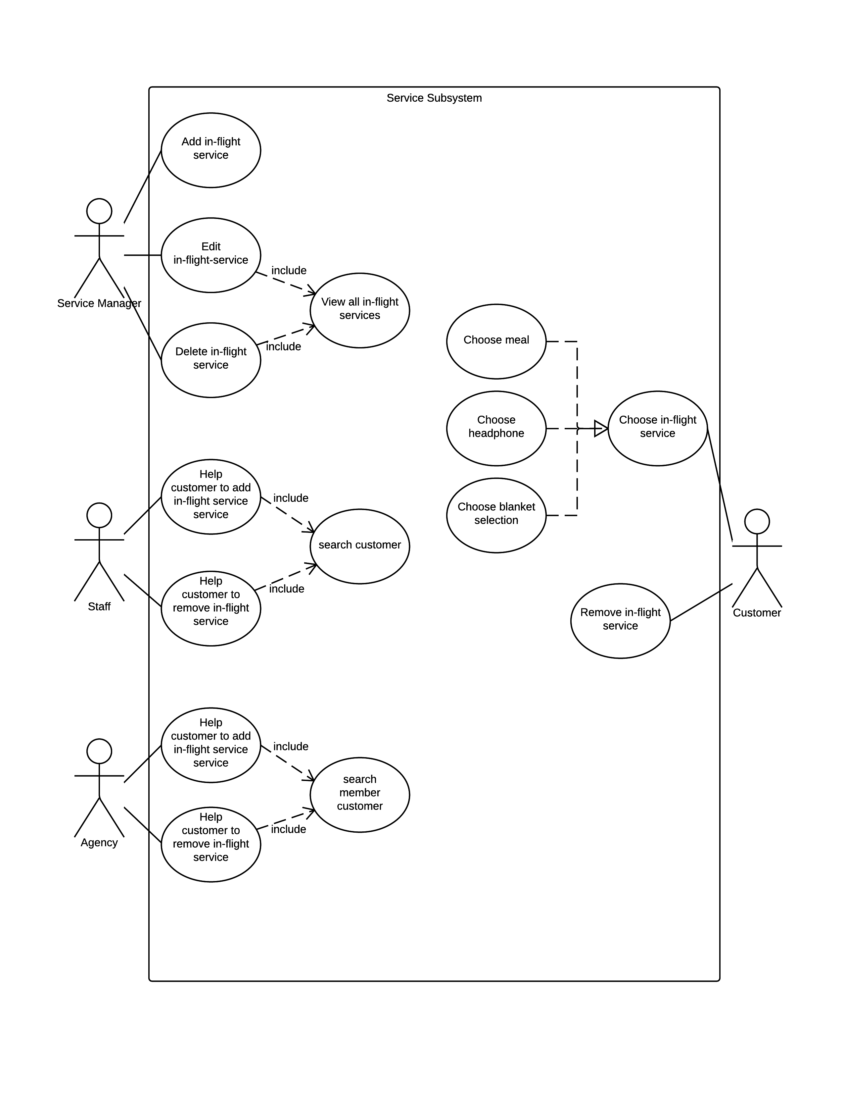Service Subsystem

|  |  |
| --- | --- |
| **Name: add in-flight service** | **ID: SS_01** |
| **Stakeholders and goals:**  All user (service managers) – want to add more inflight service | |
| **Description:** **The user want to add more inflight service in list.** | |
| **Actors: service managers** | |
| Trigger: The user want to let custom have more inflight to choose | |
| Normal flow:  1. System have a button about alter service.  2. The user press this button  3. System will display all service and these can be edit.  4. user press add button  5. System will display some selection about service.  6. user can complete these and press add  7. system can add this service in the page. | |
| **Sub-flows:**   1. Log in.(PS_02) 2. Press the service system button. | |
| **Alternative/Exceptional flows:**  None. | |

|  |  |
| --- | --- |
| **Name: edit in-flight service** | **ID: SS_02** |
| **Stakeholders and goals:**  All user (service managers) – want to edit inflight service | |
| **Description:** **The user want to edit inflight service in list, let it be better.** | |
| **Actors: service managers** | |
| Trigger: The user want to change the detail about inflight service. | |
| Normal flow:  1. System have a button about alter service.  2. The user press this button  3. System will display all service and these can be edit.  4. user change some detail and press edit button  5. System will update this service. | |
| **Sub-flows:**   1. Log in.(PS_02) 2. Press the service system button. | |
| **Alternative/Exceptional flows:**  None. | |

|  |  |
| --- | --- |
| **Name: delete in-flight service** | **ID: SS_03** |
| **Stakeholders and goals:**  All user (service managers) – want to delete inflight service | |
| **Description:** **The user want to delete some not need inflight service in list.** | |
| **Actors: service managers** | |
| Trigger: The user think some service cannot be realized, so needing delete. | |
| Normal flow:  1. System have a button about alter service.  2. The user press this button  3. System will display all service and these can be edit.  4. User choose someone and press the delete button.  5. System will remove the service from the list. | |
| **Sub-flows:**   1. Log in.(PS_02) 2. Press the service system button. | |
| **Alternative/Exceptional flows:**  None. | |

|  |  |
| --- | --- |
| **Name: view all in flight service** | **ID: SS_04** |
| **Stakeholders and goals:**  All user (service managers) – want to view all service | |
| **Description:** **The user want to let all service display on a page** | |
| **Actors: service managers** | |
| Trigger: The user want to view all service. | |
| Normal flow:  1. System have a button about our service.  2. The user press this button  3. System will display all service. | |
| **Sub-flows:**   1. Log in.(PS_02) 2. Press the service system button. | |
| **Alternative/Exceptional flows:**  None. | |

|  |  |
| --- | --- |
| **Name: help custom add service** | **ID: SS_05** |
| **Stakeholders and goals:**  All user (service managers, staff, agency) – want to help custom add service | |
| **Description:** **user can go in custom account and help them add service.** | |
| **Actors: service managers, staff, agency** | |
| Trigger: custom don’t know how to add service, so others need help them to change. | |
| Normal flow:  1. System display all flight which is booked  2. The user choose one of them  3. System will display all service, and have two button about delete and add.  4. when user press add button  5. system will display service list  6. user can choose one or more, and press add button  7. System will display it in page. | |
| **Sub-flows:**   1. Log in.(PS_02) 2. Press the service system button. 3. Choose change service button. 4. Search custom. | |
| **Alternative/Exceptional flows:**  None. | |

|  |  |
| --- | --- |
| **Name: help custom remove service** | **ID: SS_06** |
| **Stakeholders and goals:**  All user (service managers, staff, agency) – want to help custom remove service | |
| **Description:** **user can go in custom account and help them remove service.** | |
| **Actors: service managers, staff, agency** | |
| Trigger: custom don’t know how to remove service, so others need help them to change. | |
| Normal flow:  1. System display all flight which is booked  2. The user choose one of them  3. System will display all service, and have two button about delete and add.  4. when user press delete button  5. System will remove it from page. | |
| **Sub-flows:**   1. Log in.(PS_02) 2. Press the service system button. 3. Choose change service button. 4. Search custom. | |
| **Alternative/Exceptional flows:**  None. | |

|  |  |
| --- | --- |
| **Name: search custom** | **ID: SS_07** |
| **Stakeholders and goals:**  All user (service managers, staff, agency) – want to search the custom | |
| **Description:****user want to find custom account and help them** | |
| **Actors: service managers, staff, agency** | |
| Trigger: user want to find user’s information. | |
| Normal flow:  1. System display change service button  2. The user choose this  3. System will ask the email about custom  4. user can file it, and press next  5. System will display this custom’s booking flight. | |
| **Sub-flows:**   1. Log in.(PS_02) 2. Press the service system button. | |
| **Alternative/Exceptional flows:**  None. | |

|  |  |
| --- | --- |
| **Name: choose inflight service** | **ID: SS_08** |
| **Stakeholders and goals:**  All user (custom) – want to add service | |
| **Description:** **user want to add more service for themselves.** | |
| **Actors: custom** | |
| Trigger: custom want to have more service for booking flight. | |
| Normal flow:   1. System have button about change flight service 2. User can press this button.   3. System display all flight which is booked  4. The user choose one of them  5. System will display all service, and have two button about delete and add.  6. when user press add button  7. System will display service list about meal, headphone and blanket.  8. user can choose one or more, and press add button  9. System will display it in page. | |
| **Sub-flows:**   1. Log in.(PS_02)   2. Press the service system button.  3. Choose change service button.  4 Search custom. | |
| **Alternative/Exceptional flows:**  None. | |

|  |  |
| --- | --- |
| **Name: remove inflight service** | **ID: SS_09** |
| **Stakeholders and goals:**  All user (custom) – want to delete service | |
| **Description:** **user want to delete service for themselves.** | |
| **Actors: custom** | |
| Trigger: custom don’t want some service for flight. | |
| Normal flow:   1. System have button about change flight service 2. User can press this button.   3. System display all flight which is booked  4. The user choose one of them  5. System will display all service, and have two button about delete and add.  6. user can choose one or more, and press delete button  9. System will remove this from page. | |
| **Sub-flows:**  1.Log in.(PS_02)  2. Press the service system button. | |
| **Alternative/Exceptional flows:**  None. | |

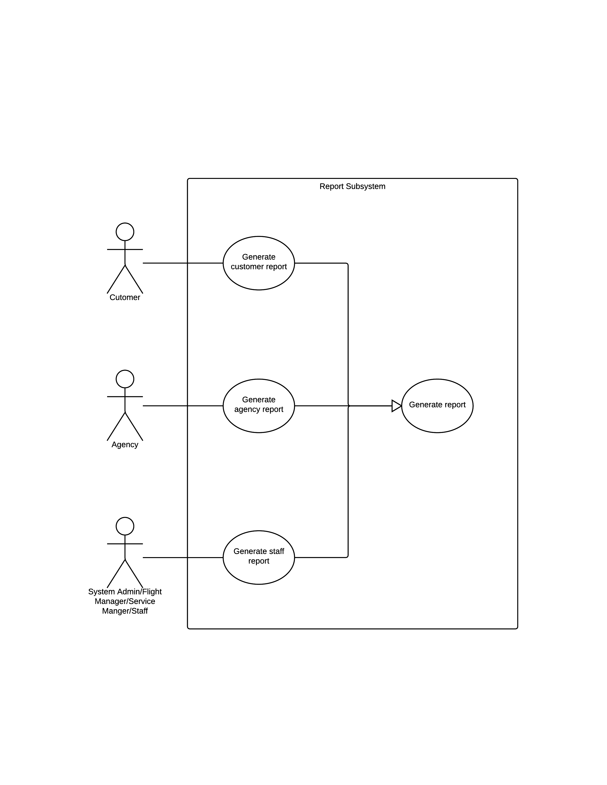Report Subsystem

|  |  |
| --- | --- |
| **Name: generate custom report** | **ID: RP_01** |
| **Stakeholders and goals:**  Custom can get the custom report | |
| **Description:** **The user can let system display custom report.** | |
| **Actors: custom** | |
| Trigger: The user want to generate custom report. | |
| Normal flow: | |
| **Sub-flows:**   1. Log in.(PS_02) 2. Press the report system button. | |
| **Alternative/Exceptional flows:**  None. | |

|  |  |
| --- | --- |
| **Name: generate agency report** | **ID: RP_02** |
| **Stakeholders and goals:**  agency can get the agency report | |
| **Description:** **The user can let system display agency report.** | |
| **Actors: custom** | |
| Trigger: The user want to generate agency report. | |
| Normal flow: | |
| **Sub-flows:**   1. Log in.(PS_02) 2. Press the report system button. | |
| **Alternative/Exceptional flows:**  None. | |

|  |  |
| --- | --- |
| **Name: generate staff report** | **ID: RP_03** |
| **Stakeholders and goals:**  Staff, manager can get the staff report | |
| **Description:** **The user can let system display staff report.** | |
| **Actors: Staff, manager** | |
| Trigger: The user want to generate staff report. | |
| Normal flow: | |
| **Sub-flows:**   1. Log in.(PS_02) 2. Press the report system button. | |
| **Alternative/Exceptional flows:**  None. | |